Supply Chain Management — Week 3
Session 2: Operations–Finance Interface & DuPont Model (Return on Assets)
Course: Supply Chain Digitization
Session Context & Scope
- Previous session: Corporate strategy → functional strategies (design, marketing, operations) — all intertwined
- This session: Interface between Operations & Finance
- Finance metric focus: Return on Assets (ROA) — one metric from DuPont Model
- Note: Finance is vast — ROA is chosen as a primer for SCM students
- Emerging area to explore further: Supply Chain Finance (smart contracting, blockchain, etc.)
DuPont Model — Adapted for Operations
What is the DuPont Model?
- A popular financial analysis framework used to derive performance indicators
- Used here in adapted form — not exact original DuPont model
- Central metric: Return on Assets (ROA)
Core Formula
ROA = Net Profit Margin × Asset Turnover Ratio
- Both are derived indicators — calculated from other metrics, not directly measured
- Goal: Maximize both to maximize ROA
★ Derived indicator = calculated through a mathematical formula from other metrics. Opposite of directly measured indicators.
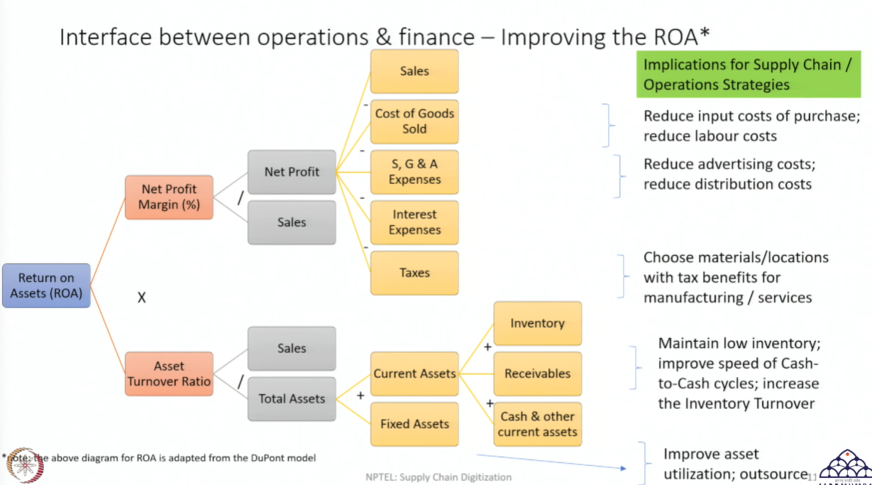
Part 1: Net Profit Margin (Derived indicator)
Definition
Net Profit Margin = Net Profit / Sales
- Ratio: How much profit is earned as a proportion of sales
- Can range from <1% to >100% — higher is better for the firm
Sales
Sales = Price per unit × Volume (units sold)
- E.g., Price = ₹100, Units sold = 10,000 → Sales = ₹10,00,000
Net Profit
Net Profit = Sales − COGS − SGA − Interest Expenses − Taxes − ...
- All these are deductions from revenue — firm owes to many entities
Cost of Goods Sold (COGS)
- All costs directly related to producing and distributing the product
- Cost of purchase: amount paid to vendors for raw materials
- Labour cost: workers involved in manufacturing — packaging, cleaning, equipment setup, material movement, etc.
- Directly linked to the activity of creating and delivering the product
SGA Expenses — Selling, General & Administrative
- Costs not directly linked to manufacturing the product
- Selling: advertisement and promotion costs
- General & Administrative: IT staff, infrastructure management, customer relations, non-shop-floor employees
- Wages for such employees are SGA, not COGS
Other Deductions
- Interest expenses: cost of borrowing from banks
- Taxes: income tax payable to government
★ Firm owes money to: vendors (COGS), employees (COGS + SGA), bank (interest), government (tax). All reduce net profit.
Operations Strategy Levers for Net Profit Margin
- Reduce cost of inputs (raw material procurement) → lower COGS
- Reduce labour cost → lower COGS
- Reduce advertising / distribution costs → lower SGA
- Choose tax-advantaged locations (e.g., manufacturing in an SEZ) → lower tax liability
- Increase sales volume / price → higher revenue base
Part 2: Asset Turnover Ratio (Derived indicator)
Definition
Asset Turnover Ratio = Sales / Total Assets
- Ratio: How much sales are generated per unit of assets owned
- Higher = better — means assets are being utilized efficiently to generate revenue
- Want: Just enough assets to generate high sales — no idle/excess assets
Total Assets = Current Assets + Fixed Assets
Fixed Assets
- Physical assets used to produce/deliver the product — not sold as product
- Examples: Manufacturing plants, factories, equipment, fleet of vehicles
- Part of capital expenditure — expensive to buy AND sell
- Not easily liquidated — take time to purchase and sell
- Support production/delivery but do not directly convert to cash
Current Assets
- Assets that can be quickly liquidated (converted to cash) — typically within the year
- Inventory:
  - Finished goods, work-in-process (WIP), raw materials
  - E.g., Shampoo bottle = finished goods; dyes, chemicals, plastic = WIP
  - Can be sold in market → generates cash
- Receivables:
  - Money owed to firm by customers who purchased on credit
  - More common in B2B settings than B2C — businesses operate on credit terms
  - Can be liquidated → treated as current asset
- Cash & Other Current Assets:
  - Already liquid — immediately available to finance operations
  - Used for: paying wages, paying small vendors, day-to-day expenses
★ Current assets = keep operations running day-to-day. Fixed assets = enable production & revenue generation. Both are needed — but excess of either is inefficient.
Operations Strategy Levers for Asset Turnover Ratio
- Reduce excess inventory → lower current assets, better turnover
- Increase inventory turnover — move stock out to consumer quickly
- Improve cash-to-cash cycle speed — how fast cash is regenerated from operations
- Improve asset utilization — ensure equipment/machinery is used to maximum capacity
- If assets are expensive → consider outsourcing to reduce fixed asset ownership
Critical Insight: Levers Are Interconnected — Not Independent
- Improving one lever impacts other levers — cannot optimize in isolation
- E.g., Increasing advertising (higher SGA) may increase sales — net effect on profit margin unclear
- E.g., Reducing inventory too aggressively → stockouts → lower sales
- E.g., Outsourcing reduces fixed assets but increases operational expenses (3PL fees)
- Operations strategy must be designed with systemic awareness of all interactions
- Also: ROA is just one indicator — do not optimize for ROA alone
- Other indicators matter too: quick ratio, current ratio, ROCE, inventory days, etc.
★ Design strategy by looking at multiple financial indicators together — not one in isolation.
Industry Examples — Operations Strategy Linked to Financial Performance
Example 1: Electric Vehicles for Last-Mile Delivery
- Context: Same-day / 10-minute delivery → high operational cost (fuel, manpower, multiple trips)
- India: ~50%+ of logistics cost = transportation cost (mainly fuel-dependent road transport)
Solution:
- Electric Vehicles (EV) for last-mile delivery
- EV charged via renewable energy → not dependent on conventional fuel
- EV operating cost significantly lower than fuel-based motorcycle
- Impact on DuPont: Reduces COGS / operating cost → improves Net Profit Margin → improves ROA
- Seen in: Food delivery, grocery delivery sectors in India
Example 2: Asset-Light Model via 3PL (Third-Party Logistics)
- Context: High logistics cost in India → difficult for individual firm to own & manage full fleet
- Solution: Outsource to 3PL providers
- 3PL aggregates volumes from multiple clients → economies of scale
- 3PL further outsources transport to service providers who own vehicles
- 3PL passes cost savings to client through bulk volume negotiation
- Impact on DuPont: Firm removes fixed assets (no owned vehicles) → improves Asset Turnover Ratio → improves ROA
- This is the asset-light model — firm uses assets without owning them
Example 3: Digital Transformation — Automating Information Processing
- Context: Manual order processing, documentation, email management → wastes time + increases admin cost
- Solutions adopted:
  - Email automation: reduce manual interaction for routine communications
  - E-commerce order management systems: sellers and buyers negotiate without manual intervention
- Impact: Reduces SGA / admin expenses → improves Net Profit Margin
Example 4: UX-Driven Inventory Turnover in E-Commerce
- Context: E-commerce platforms need to move inventory out quickly from warehouses/fulfillment centers
- Strategy: Clever website / app design to increase consumer footfall and speed of purchase
- Better navigation → consumer selects → pays → exits quickly or buys more
- Impact: Higher sales + faster inventory liquidation → improves Asset Turnover Ratio
- Also: Reduces amount of inventory held in system at any given time
- Shows: Even digital design decisions have direct financial performance implications
Session Summary
- DuPont Model: ROA = Net Profit Margin × Asset Turnover Ratio
- Net Profit Margin: Sales − COGS − SGA − Interest − Tax. Improve by: cut input/labour/admin/ad costs, choose tax-advantaged locations
- Asset Turnover Ratio: Sales / Total Assets. Improve by: reduce inventory, improve utilization, outsource fixed assets
- Key warning: All levers interact. Optimizing one can hurt another. Use multiple indicators.
- Industry examples: EVs → cut fuel cost | 3PL → asset-light | Digitization → cut admin cost | UX design → boost inventory turnover
★ Exam tip: If asked how operations strategy connects to financial performance — use DuPont framework. Trace any SC decision (e.g., outsourcing, lean inventory, EV adoption) through to its impact on Net Profit Margin or Asset Turnover Ratio → then to ROA.
★ Supply Chain Finance is an emerging area (blockchain, smart contracts) — worth reading beyond this course.

